# Report on SSLC Data Analysis

**Group No. 06**

Submitted by:

Ankit Mishra (MT201409)

Shan Mehrotra (MT20140111)

Kumar Rahul (MT2014058)

## Negative observations

* 1. **Category wise performance comparison :**

Here number of students failed in different category is shown.

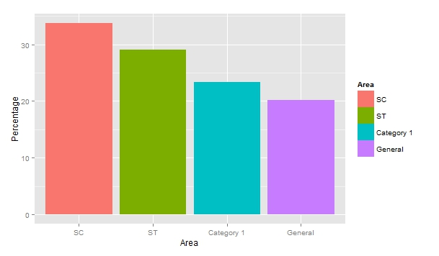

**R Code :**

#Measuring performance of students in different castes

caste1_data <- filter(g6, NRC_CASTE_CODE == 1)#SC

count(caste1_data)

mean(caste1_data$TOTAL_MARKS)

ggplot(caste1_data, aes(x=caste1_data$TOTAL_MARKS)) + geom_histogram(binwidth=5, color = "black", fill = "#FFFFE0")

caste2_data <- filter(g6, NRC_CASTE_CODE == 2)#ST

count(caste2_data)

mean(caste2_data$TOTAL_MARKS)

ggplot(caste2_data, aes(x=caste2_data$TOTAL_MARKS)) + geom_histogram(binwidth=5, color = "black", fill = "#FFFFE0")

caste3_data <- filter(g6, NRC_CASTE_CODE == 3)#Cat1

count(caste3_data)

mean(caste3_data$TOTAL_MARKS)

ggplot(caste3_data, aes(x=caste3_data$TOTAL_MARKS)) + geom_histogram(binwidth=5, color = "black", fill = "#FFFFE0")

caste4_data <- filter(g6, NRC_CASTE_CODE == 4)#Gen

count(caste4_data)

mean(caste4_data$TOTAL_MARKS)

ggplot(caste4_data, aes(x=caste4_data$TOTAL_MARKS)) + geom_histogram(binwidth=5, color = "black", fill = "#FFFFE0")

#Failed student percentage in all categories

#SC

#caste1_fail_data <- filter(caste1_data, NRC_RESULT == 'F')

caste1_fail_perc <- (sum(g6$NRC_RESULT=='F' & g6$NRC_CASTE_CODE==1)/sum(g6$NRC_CASTE_CODE==1))*100

caste1_fail_perc

#ST

#caste2_fail_data <- filter(caste2_data, NRC_RESULT == 'F')

caste2_fail_perc <- (sum(g6$NRC_RESULT=='F' & g6$NRC_CASTE_CODE==2)/sum(g6$NRC_CASTE_CODE==2))*100

caste2_fail_perc

#Cat1

#caste3_fail_data <- filter(caste3_data, NRC_RESULT == 'F')

caste3_fail_perc <- (sum(g6$NRC_RESULT=='F' & g6$NRC_CASTE_CODE==3)/sum(g6$NRC_CASTE_CODE==3))*100

caste3_fail_perc

#Gen

#caste4_fail_data <- filter(caste4_data, NRC_RESULT == 'F')

caste4_fail_perc <- (sum(g6$NRC_RESULT=='F' & g6$NRC_CASTE_CODE==4)/sum(g6$NRC_CASTE_CODE==4))*100

caste4_fail_perc

caste_fail_data <- data.frame(Area = factor(c("SC","ST","Category 1","General"), levels=c("SC","ST","Category 1","General")), Percentage = c(caste1_fail_perc, caste2_fail_perc,caste3_fail_perc,caste4_fail_perc))

ggplot(data=caste_fail_data, aes(x=Area, y=Percentage, fill=Area)) + geom_bar(stat="identity")

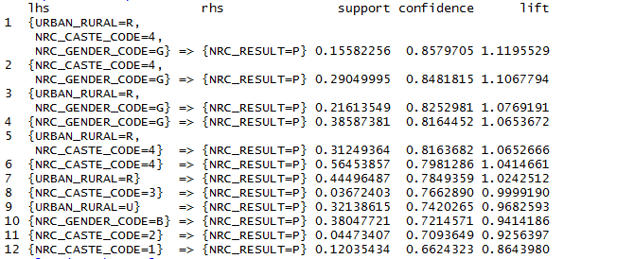

Fig. : Association Rule Mining

**R Code :**

#Performing Association Rule Mining on Caste Data

library(arules)

arule_data <- g6[,c(6,12,13,30)]

arule_data$NRC_CASTE_CODE <- as.factor(arule_data$NRC_CASTE_CODE)

tbl_df(arule_data)

rules <- apriori(arule_data)

inspect(rules)

rules <- apriori(arule_data, parameter = list(minlen = 2, supp = 0.005, conf = 0.6), appearance = list(rhs=c("NRC_RESULT=F","NRC_RESULT=P"),default = "lhs"), control = list(verbose = T))

rules.sorted <- sort(rules, by="lift")

inspect(rules.sorted)

#pruning redundant rules

subset.matrix <- is.subset(rules.sorted, rules.sorted)

subset.matrix[lower.tri(subset.matrix, diag=T)] <- NA

redundant <- colSums(subset.matrix, na.rm=T) >= 1

which(redundant)

# remove redundant rules

rules.pruned <- rules.sorted[!redundant]

inspect(rules.pruned)

#plotting the arules

library(arulesViz)

plot(rules.pruned, method="graph", control=list(type="items"))

plot(rules.pruned, method="paracoord", control=list(reorder=TRUE))

**Observation:**

* The number of student failed in SC/ST category is more.
* Maximum number of students passed lies in general category.
* From the association rules 1,2,5,6, we can observe that confidence of general category students are better than other categories.

**Conclusion:**

* Students lying in SC/ST category have poor performance.

**b. Subject important for distinction :**

Performing Discretization + Classification

Here a=Fail, b=Pass, c=2, d=1, e=Distinction

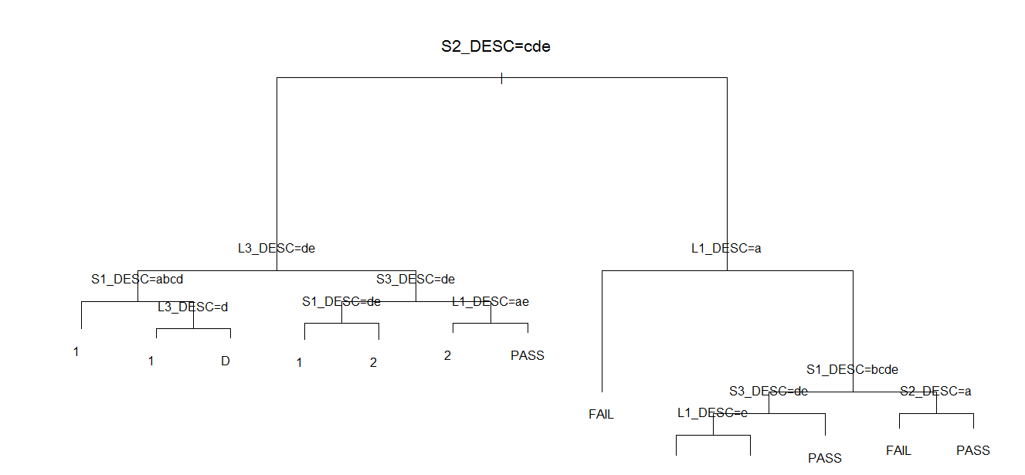

**R Code :**

#Performing Discretization + Classification

library(rattle)

library(rpart.plot)

library(RColorBrewer)

g6$L1_DESC<-cut(g6$L1_MARKS,c(0,30,45,60,80,100),labels=c('F','P','2','1','D'))

g6$L2_DESC<-cut(g6$L2_MARKS,c(0,30,45,60,80,100),labels=c('F','P','2','1','D'))

g6$L3_DESC<-cut(g6$L3_MARKS,c(0,30,45,60,80,100),labels=c('F','P','2','1','D'))

g6$S1_DESC<-cut(g6$S1_MARKS,c(0,30,45,60,80,100),labels=c('F','P','2','1','D'))

g6$S2_DESC<-cut(g6$S2_MARKS,c(0,30,45,60,80,100),labels=c('F','P','2','1','D'))

g6$S3_DESC<-cut(g6$S3_MARKS,c(0,30,45,60,80,100),labels=c('F','P','2','1','D'))

ind<-sample(2,nrow(g6),replace = TRUE,prob = c(0.7,0.3))

train<-g6[ind==1,]

test<-g6[ind==2,]

myf<-NRC_CLASS~L1_DESC+L2_DESC+L3_DESC+S1_DESC+S2_DESC+S3_DESC

tree1<-rpart(myf,data = train,control = rpart.control(minsplit = 10))

plot(tree1)

text(tree1)

print(tree1)

fancyRpartPlot(tree1)

#predicting the NRC_CLASS

Prediction <- predict(tree1, test, type = "class")

Prediction

submit <- data.frame(original_value= test$NRC_CLASS,predicted_value=Prediction)

submit

table(submit$original_value==submit$predicted_value)

xtab <- table(submit$original_value,submit$predicted_value)

library(caret)

confusionMatrix(xtab) #all necessary parameters

**Conclusion:**

* Subjects L3 and S2 are important for getting distinction.

**c. Percentage distribution for failed students :**

Histogram showing percentage distribution of failed students.

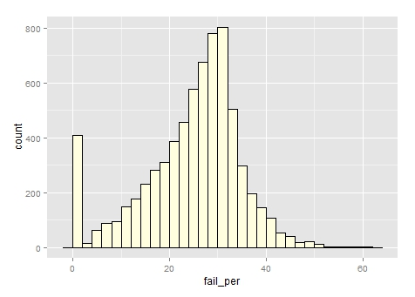

**R Code :**

fail <- filter(g6, NRC_RESULT == 'F')

fail_per <- (fail$TOTAL_MARKS/650)*100

ggplot(fail, aes(x=fail_per)) + geom_histogram(binwidth=2, color = "black", fill = "#FFFFE0")

**Observation :**

* The data contain students whose result is shown failed even after getting more than 35 percent marks.

## Positive observations

* 1. **Comparing urban and rural students :**

Considering either L1=E and L2=k or L1=k and L2=E.

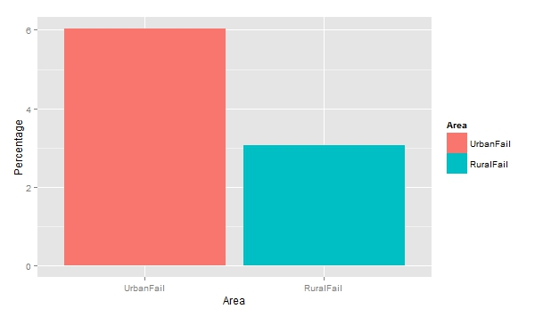

Fig.: L1=k and L2=E.

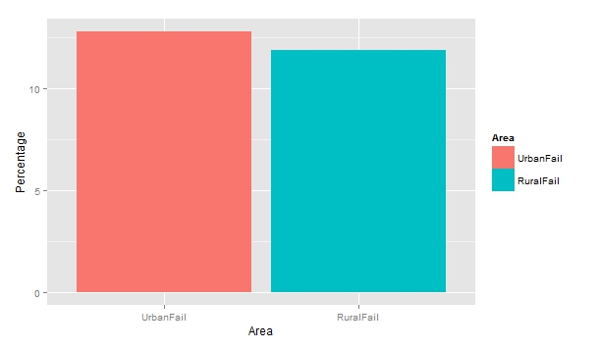

Fig.: L1=E and L2=K.

**R Code:**

#extracting L1 = K and L2 = E in urban

urb_school_L2_data <- filter(g6, URBAN_RURAL == "U", L1_CODE == "01K",L2_CODE == "31E")

str(urb_school_L2_data)

urb_l2_mean <- mean(urb_school_L2_data$L2_MARKS)

table(urb_school_L2_data$L2_MARKS)

#extracting L1 = K and L2 = E in rural

rur_school_L2_data <- filter(g6, URBAN_RURAL == "R", L1_CODE == "01K",L2_CODE == "31E")

str(rur_school_L2_data)

rur_l2_mean <- mean(rur_school_L2_data$L2_MARKS)

#drawing histogram for both data

library(ggplot2)

#ggplot(urb_school_L2_data, aes(x=urb_school_L2_data$L2_MARKS)) + geom_histogram(binwidth=2, color = "black", fill = "#FFFFE0")

#ggplot(rur_school_L2_data, aes(x=rur_school_L2_data$L2_MARKS)) + geom_histogram(binwidth=2, color = "black", fill = "#FFFFE0")

#calculating mean marks in L2 = E

urb_l2_mean <- mean(urb_school_L2_data$L2_MARKS)

rur_l2_mean <- mean(rur_school_L2_data$L2_MARKS)

#Percentage of students failed in L2 = E in urban

#urb_l2_fail <- filter( urb_school_L2_data,L2_RESULT == "F")

urb_l2_fail_perc <- (sum( urb_school_L2_data$L2_RESULT == "F") / sum(urb_school_L2_data$L2_RESULT=='F' | urb_school_L2_data$L2_RESULT=='P')) * 100

urb_l2_fail_perc #12.46%

#Percentage of students failed in L2 = E in rural

#rur_l2_fail <- filter(rur_school_L2_data, L2_RESULT == "F")

rur_l2_fail_perc <- (sum( rur_school_L2_data$L2_RESULT == "F") / sum(rur_school_L2_data$L2_RESULT=='F' | rur_school_L2_data$L2_RESULT=='P')) * 100

rur_l2_fail_perc #11.60%

gal_fail_data <- data.frame(Area = factor(c("UrbanFail","RuralFail"), levels=c("UrbanFail","RuralFail")), Percentage = c(urb_l2_fail_perc, rur_l2_fail_perc))

ggplot(data=gal_fail_data, aes(x=Area, y=Percentage, fill=Area)) + geom_bar(stat="identity")

#extracting L1 = E and L2 = K in urban

urb_l1Eng_data <- filter(g6, URBAN_RURAL == "U", L1_CODE == "14E",L2_CODE == "33K")

urb_l1Eng_mean <- mean(urb_l1Eng_data$L1_MARKS)

urb_l1Eng_mean

#extracting L1 = E and L2 = K in rural

rur_l1Eng_data <- filter(g6, URBAN_RURAL == "R", L1_CODE == "14E",L2_CODE == "33K")

rur_l1Eng_mean <- mean(urb_l1Eng_data$L1_MARKS)

rur_l1Eng_mean

#Percentage of students failed in L1 = E in urban

#urb_l1Eng_fail <- filter(urb_l1Eng_data, L2_RESULT == "F")

urb_l1Eng_fail_perc <- (sum( urb_l1Eng_data$L2_RESULT == "F") / sum(urb_l1Eng_data$L2_RESULT=='F' | urb_l1Eng_data$L2_RESULT=='P')) * 100

urb_l1Eng_fail_perc

#Percentage of students failed in L1 = E in rural

#rur_l1Eng_fail <- filter(rur_l1Eng_data, L2_RESULT == "F")

rur_l1Eng_fail_perc <- (sum( rur_l1Eng_data$L2_RESULT == "F") / sum(rur_l1Eng_data$L2_RESULT=='F' | rur_l1Eng_data$L2_RESULT=='P')) * 100

rur_l1Eng_fail_perc

gal_fail_data <- data.frame(Area = factor(c("UrbanFail","RuralFail"), levels=c("UrbanFail","RuralFail")), Percentage = c(urb_l1Eng_fail_perc, rur_l1Eng_fail_perc))

ggplot(data=gal_fail_data, aes(x=Area, y=Percentage, fill=Area)) + geom_bar(stat="identity")

**Observation:**

* Rural students are performing better than urban student in English.

**Conclusion:**

* Rural students are performing better.
  1. **Analyzing performance of girls in rural and urban areas :**

Here number of girls failed in urban and rural areas are shown.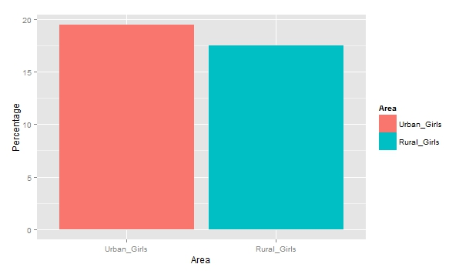

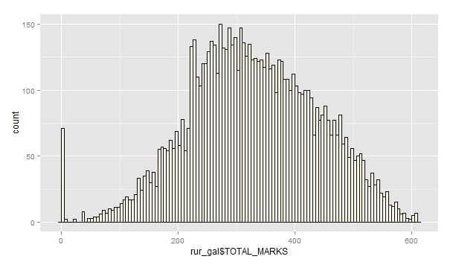

Fig. : Girls total marks in rural area.

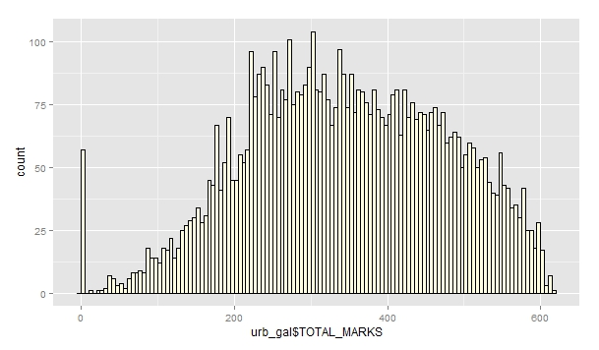

Fig. : Girls total marks in urban area.

**R Code :**

#Calculating No of girls

urb_gal <- filter(g6, URBAN_RURAL == "U", NRC_GENDER_CODE == "G")

rur_gal <- filter(g6, URBAN_RURAL == "R", NRC_GENDER_CODE == "G")

count(urb_gal)

count(rur_gal)

library(ggplot2)

#plotting histograms of total marks distribution

ggplot(urb_gal, aes(x=urb_gal$TOTAL_MARKS)) + geom_histogram(binwidth=5, color = "black", fill = "#FFFFE0")

mean(urb_gal$TOTAL_MARKS)

ggplot(rur_gal, aes(x=rur_gal$TOTAL_MARKS)) + geom_histogram(binwidth=5, color = "black", fill = "#FFFFE0")

mean(rur_gal$TOTAL_MARKS)

#No of girls failed in rural and urban areas

urb_gal_fail <- filter(urb_gal, NRC_RESULT == "F")

count(urb_gal_fail)

rur_gal_fail <- filter(rur_gal, NRC_RESULT == "F")

count(rur_gal_fail)

#Percentage of girls failed in Urban and Rural areas

#urb_gal_fail_perc <- (sum(urb_gal_fail)/sum(urb_gal))*100

#urb_gal_fail_perc #19.45%

#rur_gal_fail_perc <- (sum(rur_gal_fail)/sum(rur_gal))*100

#rur_gal_fail_perc #17.48

urb_gal_fail_perc <- (sum(g6$URBAN_RURAL == 'U' & g6$NRC_RESULT == 'F' & g6$NRC_GENDER_CODE == "G")/sum(g6$URBAN_RURAL == 'U' & g6$NRC_GENDER_CODE == "G"))*100

urb_gal_fail_perc

rur_gal_fail_perc <- (sum(g6$URBAN_RURAL == 'R' & g6$NRC_RESULT == 'F' & g6$NRC_GENDER_CODE == "G")/sum(g6$URBAN_RURAL == 'R' & g6$NRC_GENDER_CODE == "G"))*100

#Bar Chart of girls failing in Urban vs Rural

gal_fail_data <- data.frame(Area = factor(c("Urban_Girls","Rural_Girls"), levels=c("Urban_Girls","Rural_Girls")), Percentage = c(urb_gal_fail_perc, rur_gal_fail_perc))

ggplot(data=gal_fail_data, aes(x=Area, y=Percentage, fill=Area)) + geom_bar(stat="identity")

**Observation:**

* From the data, we have analyzed that girls in rural area are performing better than girls in urban area.

**Conclusion:**

* Girls in rural area are better than girls in urban area.